Limitations & Future Improvements
atos
holiday chat agent – synoptic project
Jamie Butler
2021
Contents
Limitations & Improvements 2
Known Limitation – Simple Parse Logic 2
Appropriate Improvement 2
Bugs Found in Development 2
Possible Solutions 3
Opted Solution 3

Limitations & Improvements

Known Limitation – Simple Parse Logic
Due to the extensive nature of Chat Agent parsing, the actual parsing of application is quite simple due to time constraints of the project. The logic scans the user’s input for key words, in-turn prompting the Chat Agent to render a message or a widget (custom embedded function) in the Chat Agent. Moreover, the react-chatbot-kit is a very basic boilerplate for creating a Chat Agent, leaving all the parsing logic to the developer.
Furthermore, the lack of documentation for the react-chatbot-kit posed a major limitation to the application as my knowledge on its capabilities was limited. Having more documentation on how the Action Provider interacts with the widget options, and how they can reverse trigger Action Provider functions. This would ultimately make the parsing logic much simpler, reducing the need for as many handlers. Although the react-chatbot-kit handles a large portion of the wireframing, this could easily be replicated by simple .jsx elements.

Appropriate Improvement
An appropriate improvement for the listed limitation would be to utilise a third-party product from Google called DialogueFlow. This product handles a lot of the heavy lifting with the parsing logic as it is AI driven. DialogueFlow creates the Chat Agent, and the messages can be retrieved using the built-in API calls. In addition to this, the integration with Firestore Firebase is much more efficient, being handled in the Service level, as they are both Google products, reducing the required code.

Bugs Found in Development
During development, I found a slight issue with the Chat Agent modal toggle buttons. On the Home page-route, the Chatbot toggle buttons are designed so the ChatIcon toggles the Chatbox on, and the CloseIcon closes the Chatbot window. However, due to how the source code was written, both buttons could toggle the render state of the Chatbot container. The syntax was as follows.
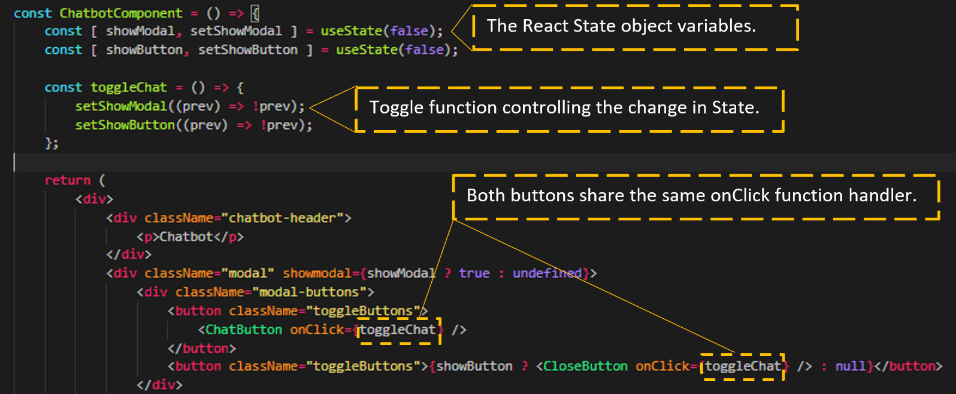

Possible Solutions
Although this iteration of code works, performing the required functionality and producing the desired outcome, it represents redundancy in the session layer exposed to the user. There are possible solutions which could be drawn upon to resolve the redundancy reaching the user.
Firstly, a new onClick function handler could be written, simply setting the state to false, allowing the CloseButton its own discrete function, removing the redundancy in the web-application.
Secondly, the CloseButton could be removed entirely; instead opting for a new conditionally rendered ChatButton to display an active style class, and a toggle button setting the inactive style class.
For usability and accessibility purposes, having a clear button for each function of opening and closing the chat bot would be more suitable for a positive user experience. Going forward, discrete functions for the onClick handler will be implemented.
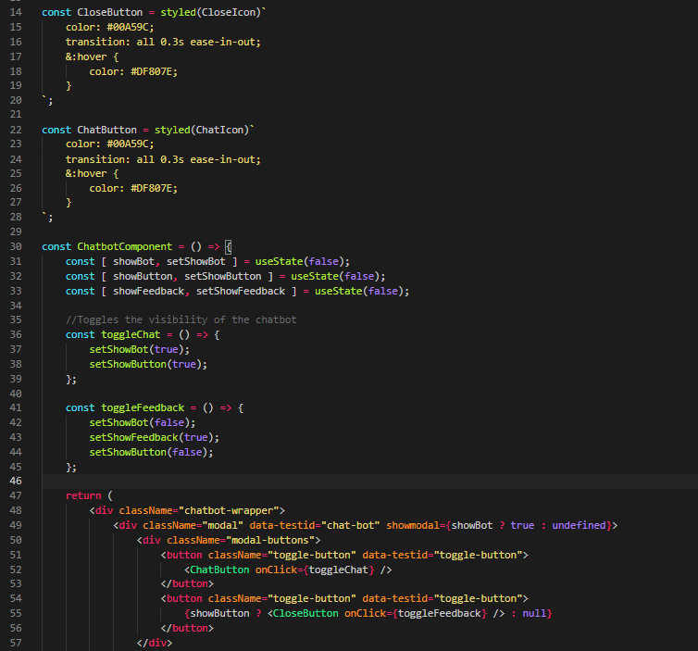

Opted Solution
The resolution came in the form of having discrete functions which manipulated state, and in-turn manipulating the visibility of the Chat Agent and the Feedback modal. The toggleChat function changes the visibility of the Chat Agent modal state in addition to the CloseButton. The new toggleFeedback function manipulates more state variables to achieve the discrete functionality. The new function removes the Chat Agent from the screen, makes the feedback modal visible (once) and sets the Chat Agent CloseButton to false.
This solution reduces the redundancy experienced by the user and clarifies the purpose and functionality of certain buttons to the user.

